Steps to run the ECOMM example project

DATABASE
PostgreSQL is used. Download and install first. PostgreSQL: Downloads
Following username and password are used in the project:
spring.datasource.username=postgres
spring.datasource.password=123456
If you choose different username and password, change these in application.properties file in the backend folder.
Create a database called ecommdb
Create the products table in this database using the following script:
-- Drop old table if it exists (optional but useful in dev)
DROP TABLE IF EXISTS products CASCADE;
-- Create products table with all columns
CREATE TABLE products (
id BIGSERIAL PRIMARY KEY,
name VARCHAR(255) NOT NULL,
description VARCHAR(500),
price NUMERIC(10, 2) NOT NULL,
image_url VARCHAR(512),
featured BOOLEAN NOT NULL DEFAULT FALSE,
details TEXT -- new detailed info column
);

Now insert data into this table using the SQL script in the data.sql file in the backend\src\main\resources folder
You should have the following table:
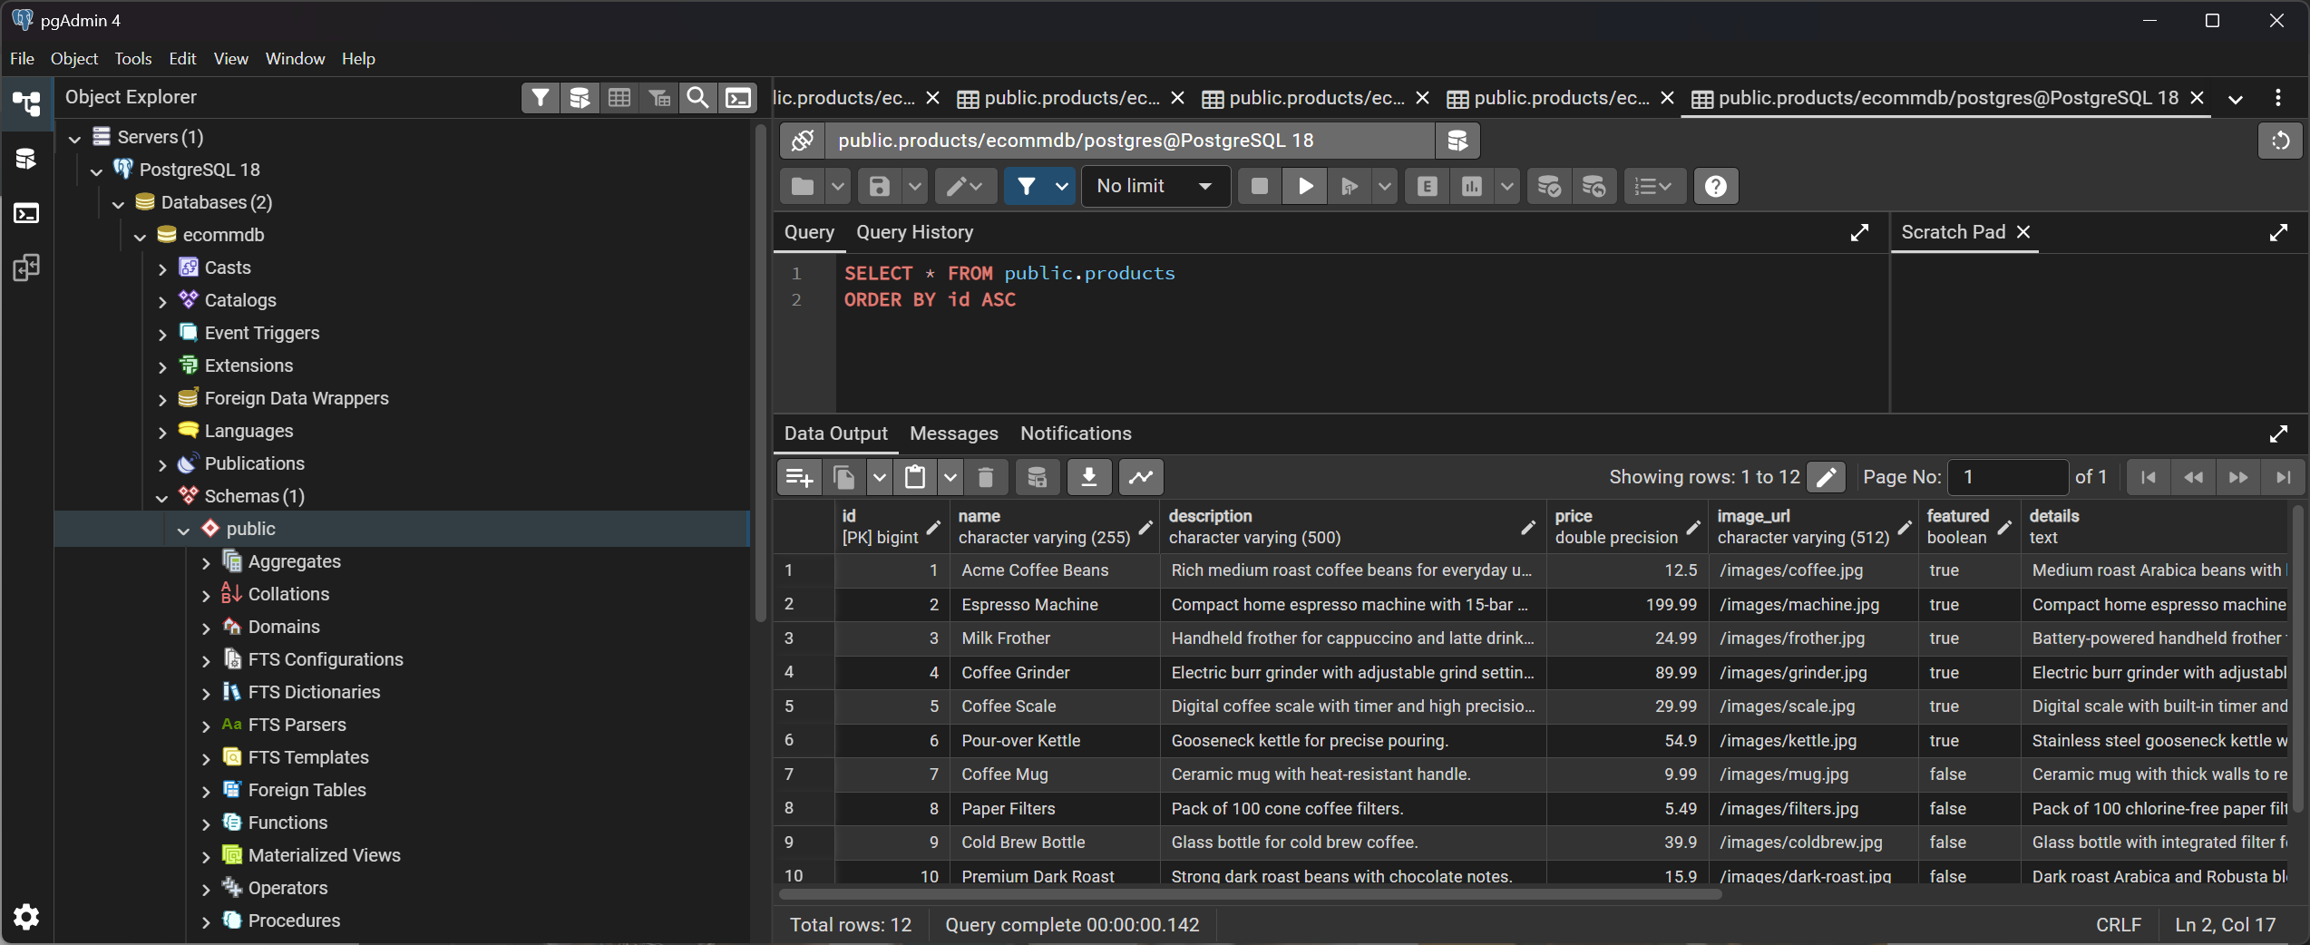

Check the port to see if DB is running or not (is something listening on 5432?)
PowerShell
netstat -ano | findstr :5432
- If you see LISTENING, something is listening on port 5432.
- If nothing shows up, Postgres is not running (or on a different port).

BACKEND
Open the backend folder in IntelliJ Community
Allow the Elevator. It will do the following:
Indexing: scans your project files to build fast search/navigation (go to class, find usages, etc.).
Detecting the build system: recognizes Maven/Gradle, reads pom.xml / build.gradle, and imports the project model.
The project folders will be excluded from the Windows Defender checks. This is normal.
Now you can run the backend project in IntelliJ.

Check if port 8080 is listening
PowerShell
netstat -ano | findstr :8080
If you see LISTENING, something is running on 8080.

FRONTEND

Open the frontend folder in Command Prompt
Run:
npm install
Wait for a while for the dependencies to be installed under node_modules folder.
Open frontend folder in VS Code
Run
npm start
in Command Prompt
After a while you should see the app running at localhost:3000

